S


Baldivis Secondary College

Semester One Examination, 2017

Question/Answer booklet

MATHEMATICS

If required by your examination administrator, please place your student identification label in this box
SPECIALIST
UNIT 1

Section Two:

Calculator-assumed

Student Number: In figures

In words

Your name

Time allowed for this section
Reading time before commencing work: ten minutes
Working time: one hundred minutes

Materials required/recommended for this section
To be provided by the supervisor
This Question/Answer booklet
Formula sheet (retained from Section One)

To be provided by the candidate
Standard items: pens (blue/black preferred), pencils (including coloured), sharpener, correction fluid/tape, eraser, ruler, highlighters

Special items: drawing instruments, templates, notes on two unfolded sheets of A4 paper, and up to three calculators approved for use in this examination

Important note to candidates
No other items may be taken into the examination room. It is your responsibility to ensure that you do not have any unauthorised material. If you have any unauthorised material with you, hand it to the supervisor before reading any further.

Structure of this paper

Section | Number of questions available | Number of questions to be answered | Working  time (minutes) | Marks available | Percentage of examination
Section One:  Calculator-free | 6 | 6 | 50 | 52 | 35
Section Two:  Calculator-assumed | 12 | 12 | 100 | 96 | 65
 |  |  |  | Total | 100

Markers use only
Question | Maximum | Mark
7 | 6
8 | 5
9 | 8
10 | 8
11 | 8
12 | 8
13 | 9
14 | 8
15 | 9
16 | 10
17 | 11
18 | 6
S2 Total | 96
S2 Wt (×0.6771) | 65%

Instructions to candidates

1. The rules for the conduct of examinations are detailed in the school handbook. Sitting this examination implies that you agree to abide by these rules.

2. Write your answers in this Question/Answer booklet.

3. You must be careful to confine your response to the specific question asked and to follow any instructions that are specified to a particular question.

4. Additional working space pages at the end of this Question/Answer booklet are for planning or continuing an answer. If you use these pages, indicate at the original answer, the page number it is planned/continued on and write the question number being planned/continued on the additional working space page.

5. Show all your working clearly. Your working should be in sufficient detail to allow your answers to be checked readily and for marks to be awarded for reasoning. Incorrect answers given without supporting reasoning cannot be allocated any marks. For any question or part question worth more than two marks, valid working or justification is required to receive full marks. If you repeat any question, ensure that you cancel the answer you do not wish to have marked.

6. It is recommended that you do not use pencil, except in diagrams.

7. The Formula sheet is not to be handed in with your Question/Answer booklet.

Section Two: Calculator-assumed 65% (96 Marks)
This section has twelve (12) questions. Answer all questions. Write your answers in the spaces provided.

Working time: 100 minutes.

Question 7 (6 marks)
A music playlist contains nine different tracks, including one called First Night and another called Last Night. Each track is three minutes long.

(a) A shuffle feature randomly arranges the nine tracks. Determine the number of all possible arrangements that

(i) start with First Night. (1 mark)

(ii) start with First Night and end with Last Night. (1 mark)

(iii) start with First Night or end with Last Night. (2 marks)

(b) Determine the number of selections of different tracks from the playlist that do not include First Night and Last Night and have a total playtime of 15 minutes. (2 marks)

Question 8 (5 marks)
In the diagram below, $AD$ and $BE$ are diameters of the circle with centre $O$, $C$ lies on the circumference and $∠COD=28°$.

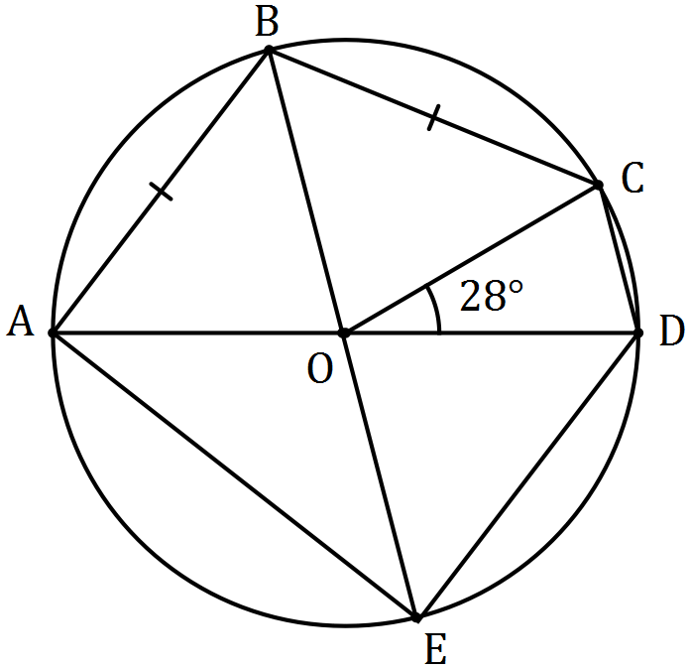

Determine the sizes of the following angles.

(a) $∠AOB$. (2 marks)

(b) $∠AEB$. (1 mark)

(c) $∠ADE$. (2 marks)

Question 9 (8 marks)
Two tugs pull an offshore drilling rig. The first tug applies a force of 5 500 N in direction 122° and the second tug applies a force of 6 000 N in direction 088°.

(a) Show that the resultant force applied by the two tugs has magnitude close to 11 000 N, and determine the angle that the resultant force makes with the direction of the force applied by the first tug boat. (5 marks)

(b) The second tug boat is asked to decrease the magnitude of the force it applies to reduce the resultant force to 9 000 N. Determine the percentage decrease required. (3 marks)

Question 10 (8 marks)
Three vectors $a$, $b$ and $c$ are non-zero and non-parallel.

(a) Sketch a diagram using the parallelogram rule to show that vector addition is commutative, that is $a+b=b+a$. (2 marks)

(b) Sketch a diagram to clearly illustrate each of the following vector equations.

(i) $a+b=c$. (2 marks)

(ii) $c-a=2b$. (2 marks)

(c) If $a+b+c=0$, then is it also true that $\hat{a}+\hat{b}+\hat{c}=0$? Explain your answer. (2 marks)

Question 11 (8 marks)
(a) In the diagram, , $B$, $C$ and $D$ lie on the circumference of circle with centre $O$. Given that $∠ADC=67°$, $∠BCO=63°$ and $∠DCO=23°$ determine the values of $a$, $b$ and $c$. (3 marks)

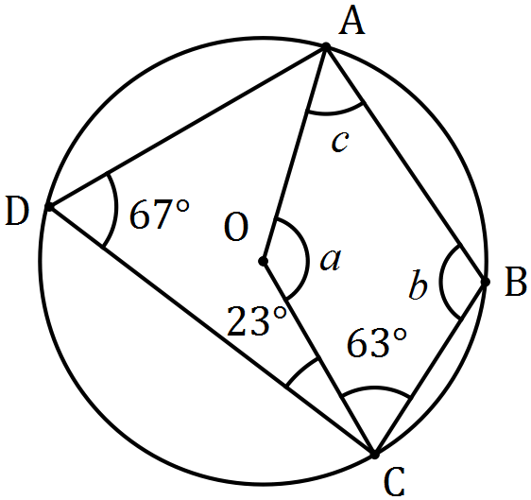

(b) In the diagram below, points $B$, $C$ and $D$ lie on the circumference of circle centre $O$ and $AB$ and $AD$ are tangents to the circle.
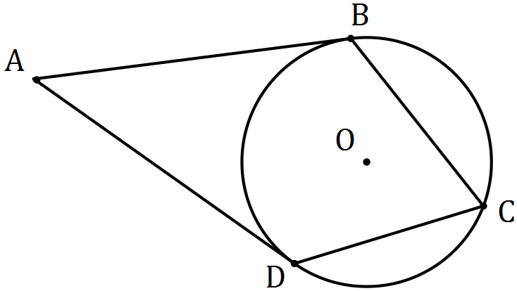

(i) Prove that $ABOD$ is a cyclic quadrilateral. (3 marks)

(ii) Determine the size of $∠BAD$ if the size of $∠BCD=78°$. (2 marks)

Question 12 (8 marks)
A seaplane with a cruising speed of 250 kmh⁻¹ is required to fly to a location 355 km away on a bearing of 305°. A wind of 36 kmh⁻¹ is blowing from bearing 020°.

(a) Sketch a diagram to show this information. (2 marks)

(b) Determine the bearing that the seaplane should steer. (3 marks)

(c) Determine the flight time, in hours and minutes. (3 marks)

Question 13 (9 marks)
Seven teams from WA, six teams from SA and five teams from NT apply for eight available places in a league competition. The league is run so that every team plays every other team exactly once and no game ends in a tie.

(a) The organisers decide that there must be at least four teams from WA and an equal number of teams from SA and NT. Determine the total number of ways in which the organisers can select the eight teams for the league. (3 marks)

Assume the eight teams have already been chosen.

(b) Determine the number of games that will be played in the league and hence the number of schedules possible for the first three games. (3 marks)

(c) Use the pigeon hole principle to show that if no team loses all its games, then at least two teams finish the competition with the same number of wins. (3 marks)

Question 14 (8 marks)
Three vectors are given by $a=3i-4j$, $b=-3i+1.5j$ and $c=-2i+yj$, where $y$ is a constant.

(a) Determine the vector projection of $b$ on $a$. (3 marks)

(b) Determine the value(s) of $y$ if

(i) $a$ and $c$ are perpendicular. (2 marks)

(ii) the angle between the directions of $b$ and $c$ is 45°. (3 marks)

Question 15 (9 marks)
(a) The work done, in joules, by a force of $F$ Newtons in changing the displacement of an object by $s$ metres, is given by the scalar product of $F$ and $s$.

(i) A force of 250 N acting due south moves an object 4.3 m in a south-westerly direction. Determine the work done. (2 marks)

(ii) Another force of 155 N does 269 joules of work in moving an object 190 cm. Determine the angle between the force and the direction of movement. (2 marks)

(b) A triangle is formed by three non-zero vectors $a$, $b$ and $c$, so that $c=a-b$, and $θ$ is the angle between $a$ and $b$.

(i) Sketch the triangle. (1 mark)

(ii) Explain why $c∙c={\left|c\right|}^{2}$. (1 mark)

(iii) Use $c∙c=\left(a-b\right)∙\left(a-b\right)$ to deduce the cosine rule. (3 marks)

Question 16 (10 marks)
In the diagram below, $POT$ is a diameter of circle with centre $O$, $QP$ is a tangent to the circle at $P$, $QR$ is a tangent to the circle at $R$ and $PT$ is extended to meet $QR$ extended at $S$. You may want to let $∠OTR=θ$.

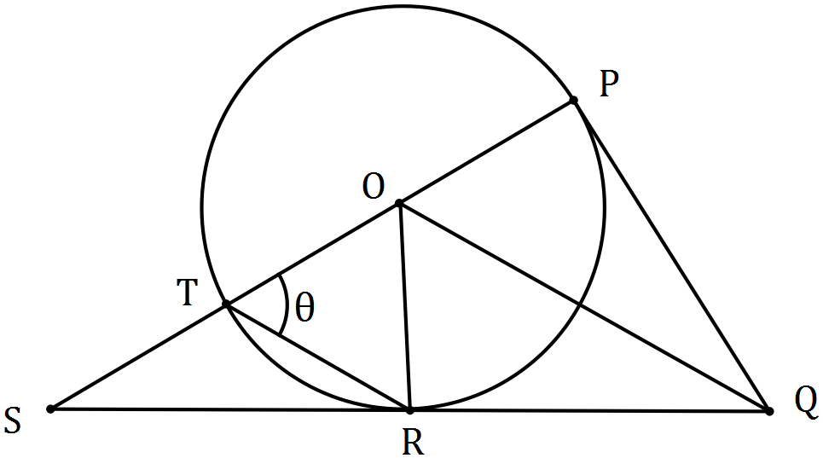

(a) Prove that $ΔOPQ$ is congruent to $ΔORQ$. (3 marks)

(b) Prove that $OQ$ is parallel to $TR$. (4 marks)

(c) If $TR=TS$, deduce that $ΔOTR$ is equilateral. (3 marks)

Question 17 (11 marks)
A small boat that can maintain a steady speed of 5 ms⁻¹ is to cross a river from $A$ to $B$, where $\vec{AB}=\left(35i-105j\right) \text{m}$.

A current of $\left(-i-2j\right) {\text{ms}}^{-1}$ flows in the river.

The velocity vector that the pilot of the small boat must set to travel from $A$ to $B$ is $ai+bj$, where $a$ and $b$ are constants.

(a) Explain why $t\left(a-1\right)=35$ and $t\left(b-2\right)=-105$, where $t$ is a constant. (3 marks)

(b) Eliminate $t$ from the equations in (a) and hence express $b$ in terms of $a$, simplifying your expression. (3 marks)

(c) Explain why $a^{2}+b^{2}=25$. (1 mark)

(d) Use your equations from (b) and (c) to determine the values of $a$ and $b$. (3 marks)

(e) Determine the time that the small boat will take to travel from $A$ to $B$. (1 mark)

Question 18 (6 marks)
Let $g\left(x\right)=x^{2}-8x+19, x∈Z$.

(a) Use an example to show that when $x$ is odd, $g\left(x\right)$ is even. (1 mark)

(b) Write the contrapositive of "if $g(x)$ is an even integer, then $x$ is an odd integer". (1 mark)

Any even integer $m$ can be expressed in the form $m=2a$, where $a∈Z$. Similarly, any odd integer $n$ can be expressed in the form $n=2a+1$.

(c) Simplify $g(2a)$. (1 mark)

(d) Express $g(2a)$ in a form that clearly shows it is an odd integer. (1 mark)

(e) Use your answers above to prove that if $g(x)$ is even, then $x$ is odd. (2 marks)

Additional working space

Question number: _________

Additional working space

Question number: _________

Additional working space

Question number: _________

© 2017 WA Exam Papers. Baldivis Secondary College has a non-exclusive licence to copy and communicate this paper for non-commercial, educational use within the school. No other copying, communication or use is permitted without the express written permission of WA Exam Papers. SN261-091-3.

